What do children think about human rights?
Hi, my name is Rebecca and my job is finding out about schools and pupils like you at the University of Manchester.
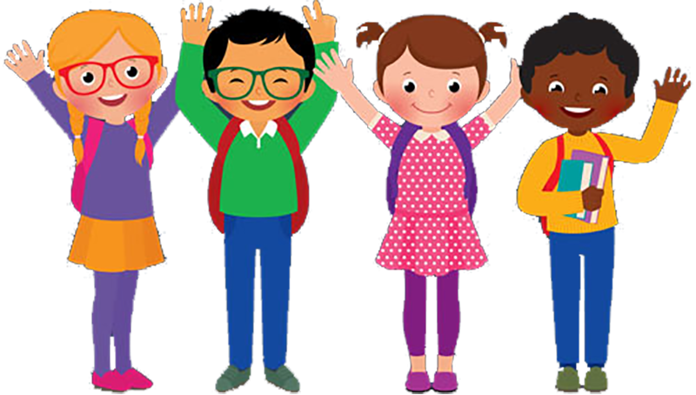
Would you like to help me with my work about what you think about human rights? You don’t have to if you don’t want to.
What am I doing?
We are all special and unique. We have different likes and dislikes; we all do different things. Sometimes we might have questions about what information we hear or see about the rights we have as people, sometimes we might want to change things about the world we live in. I am interested in knowing what you think about human rights.
What do you have to do?
If you want to help, I will ask you to:
Read a story with me about different people’s thoughts about the human rights from around the world. Talk about things in the book you find interesting or have questions about.
You might want to create an extra page for the book by drawing or writing which could say what you think too.
I will collect the book in and put it in to quarantine. Everyone who takes part will have a clean and fresh book to look at.
We will then have a group chat with other children in the study about the book and our thoughts like what you do in literacy lessons. There are no right or wrong answers.

Would that be ok?

Who gets to see your answers?
I will need to know what year group you are in and your name. Only I will know this.
I will keep your answers safe by making sure that no one else sees them other than me. I will not use your real name, I will use pretend names for your work and for your answers.
I will keep your answers for 5 years and then I will destroy them.
If you want to know more, please ask your mum, dad or the person who looks after you as I have given them a lot of extra information about this.
What will I do to help protect you from the Corona Virus?
I will be wearing a clear face mask and I will wash my hands and use sanitiser before I meet with you. I will not sit close to you. I will clean and sanitise the table and chairs in the room that we are in before you come in. All the things you have to use, like the book or paper and pens, will all be brand new and will only be used by you. After you have used them, I will put them into a special box to keep them separate from the fresh clean ones.
What can you do to help?
You can wash your hands and use the sanitiser before we start our activity and after we have finished. If you are feeling poorly then let your teacher or me know before we begin.
What Do you Do Now?
If you have any questions please ask me, your mum, dad or the person that looks after you.
Let me know if you would like to take part.

Thank you for reading this!
