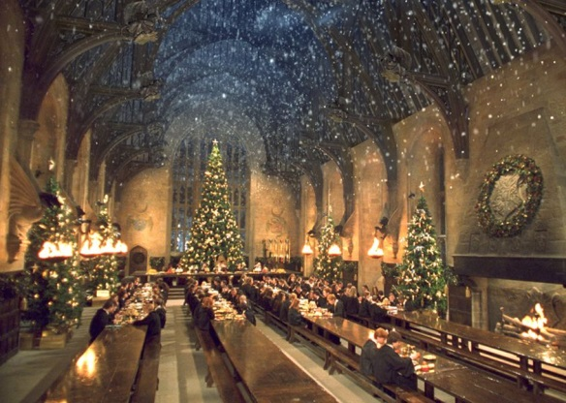The Hogwarts Gang have Christmas Shopping!

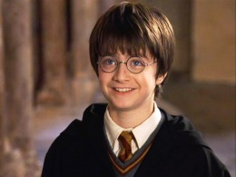

1. 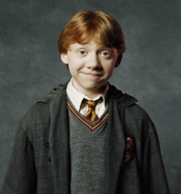Harry has **£10.00.** He spends **£7.00** on a new broom for Ron. How much does he have left?
2. 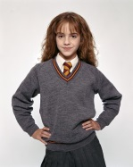Ron has **£10.00**. He spends **£2.00** on a new cage for his rat. How much does he have left?
3. 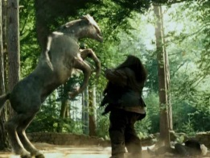Hermione has **15**.**00.** She spends **£7.00** on a new cauldron for her potions class. How much does she have left?
4. 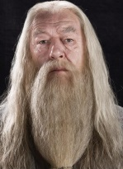Hagrid has **£15.00**. He spends **£9.00** on ferret food for Buckbeak. How much does he have left?
5. 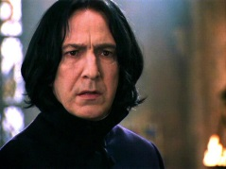Dumbledore has **£15.00.** He spends **£4.00** on Christmas decorations for Hogwarts. How much does he have left?
6. 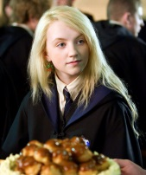Professor Snape has **£20.00**. He spends **£6.00** on a dark spells book. How much does he have left?
7. 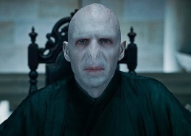Luna has **£20.00**. She spends **£12.00** on Christmas socks. How much does he have left?
8. 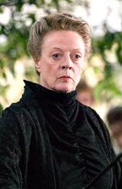Voldemort has **£20.00.** He spends **£16.00** on a new Horcrux. How much does he have left?
9. 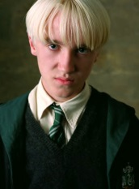 Professor Mcgonagall has **£20.00**. She spends **£7.00** on a new wand. How much does she have left?
10. Draco has **£20.00**. He spends **£14.00** on blonde hair dye. How much does he have left?