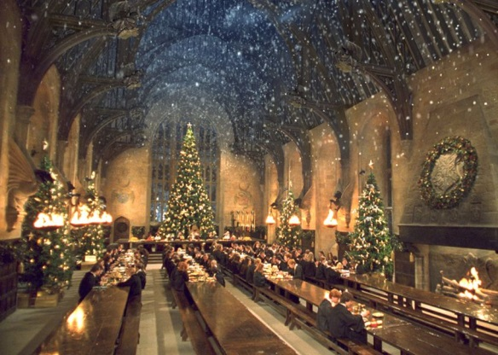The Hogwarts Gang have Christmas Shopping!

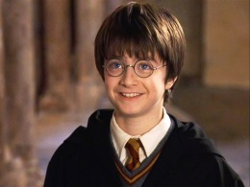

1. 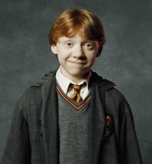Harry has £784.63. He spends £297.42 on a new broom for Ron. How much does he have left?
2. 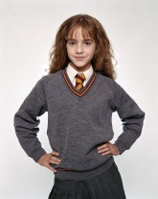Ron has £457.04. He spends £368.93 on a new cage for his rat. How much does he have left?
3. 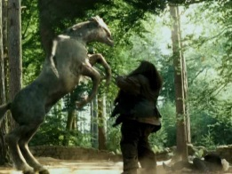Hermione has £620.49. She spends £472.67 on a new cauldron for her potions class. How much does she have left?
4. 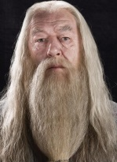Hagrid has £1275.60. He spends £965.29 on ferret food for Buckbeak. How much does he have left?
5. 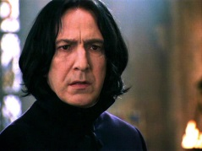Dumbledore has £3467.46. He spends £2841.30 on Christmas decorations for Hogwarts. How much does he have left?
6. 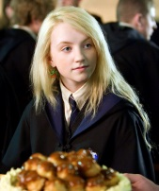Professor Snape has £109.08. He spends £69.34 on a dark spells book. How much does he have left?
7. 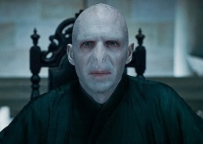Luna has £4280. She spends £420.30 on Christmas socks. How much does he have left?
8. 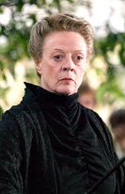Voldemort has £379.84. He spends £296.78 on a new Horcrux. How much does he have left?
9. 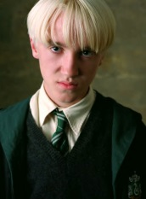 Professor Mcgonagall has £8705. She spends £3974.40 on a new wand. How much does she have left?
10. Draco has £2076. He spends £1392.31 on blonde hair dye. How much does he have left?