Aloe Vera Class – Easter Activities
Please use this list as a menu of fun activities to dip in and out of over Easter. You may have your own ideas too!
- Bake hot cross buns and eat them on Good Friday. I like this recipe: https://www.bbcgoodfood.com/recipes/hot-cross-buns
- Try the colour by number Easter activities (see below)
- Have an Easter egg hunt in the garden. Who can find the most chocolate?
- Do some Easter egg mindfulness colouring (see below)
- Design (and create if you can!) an Easter egg that Willy Wonka could make in his factory. Remember to give it an exciting name!
- Learn about the Christian Easter story and create a comic strip to show the events that happened (see below)
- Decorate a hard boiled egg and create a scene for your egg. Here are some ideas of what children have done in previous years:
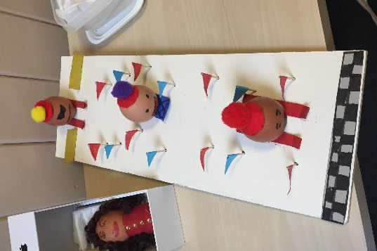
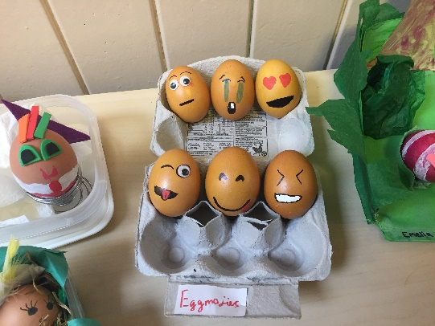
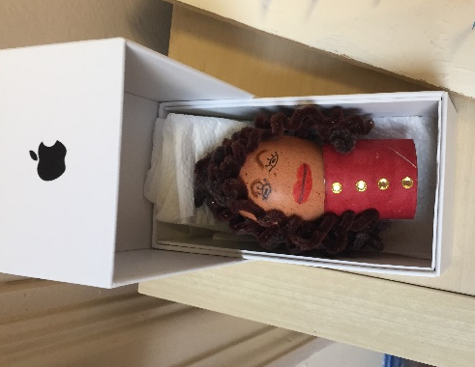
Egg-mojis!

Me as an Easter egg!
Skiing eggs!

- Write your own story set during Easter time. Maybe a chick or a bunny could be the main characters?
- Make an Easter basket (see below)
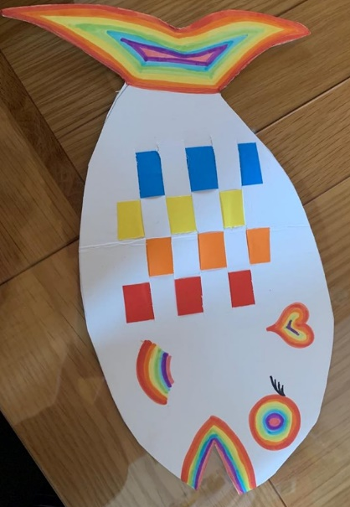
- Make cards and send them to friends or family that you aren’t able to see at the moment. I have made some at Simmondley school if you would like some examples:
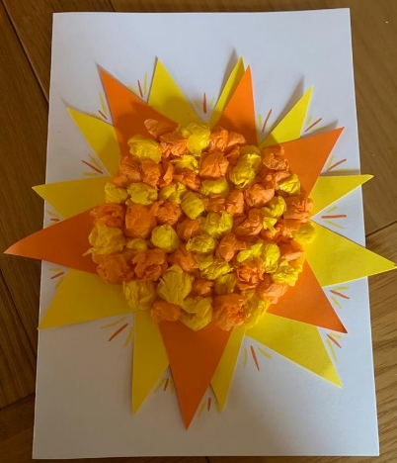

A rainbow fish with coloured card weaved through to send to my Goddaughter.
An Easter egg using card and crayons. To send to my Grandparents.
A sunshine card using screwed up tissue paper for my Godson.

Please send any pictures to Mr. Woodward so I can see all of the fun things you have been up to. Remember to have a rest too! Missing you all lots; wishing you and your families a very happy Easter! Miss Graham x

