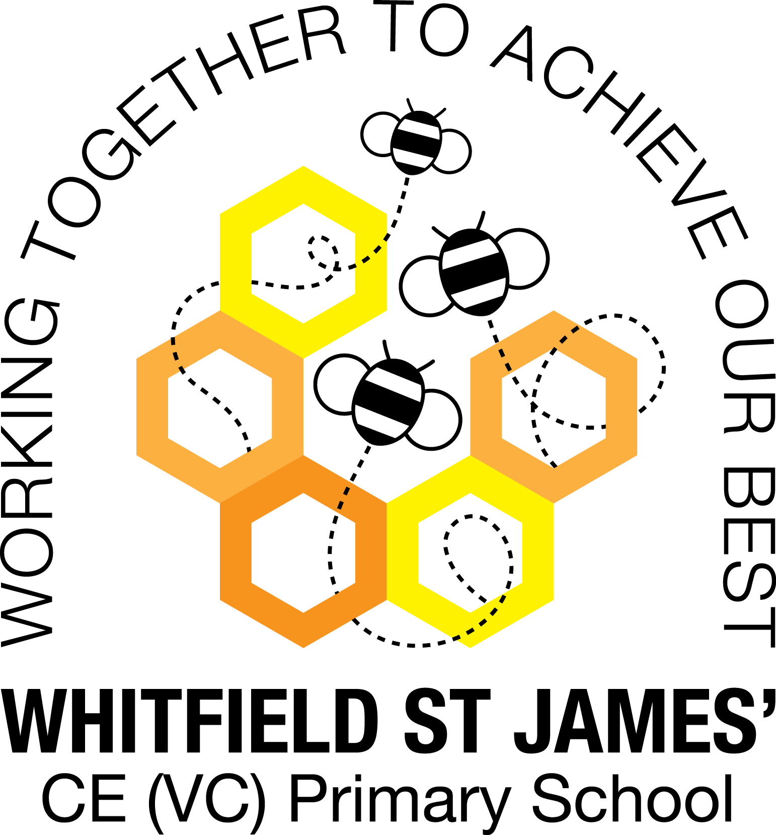

WHITFIELD ST JAMES’ CE (VC) PRIMARY SCHOOL

Early Years Parent Partnership Newsletter
Autumn 1

Welcome back, we hope you had an enjoyable summer and a big hello to all our new children and their families who are joining us this half term!

Dates for the diary

Week Commencing 21st October 2019: Autumn Activity Week
Please join us during our Autumn Activity Week, come and see what we have been learning and participate in some fabulous autumn activities with your child! Each parent will be given a slot to attend. Your child’s Teacher will be available to chat to you about your child and answer any questions you may have. Further details to follow.

October half term: Monday 28th October – Friday 1st November

Reminders
Nursery: F1

- Please pay snack money which is £7 for this half term (£1 per week)
- F1 (Nursery) please bring book bags everyday
- F1: A drawstring bag (no backpacks and for safety reasons no plastic bags please) with a change of clothes including underwear and socks
- F1: Please collect any work/paintings etc from the table at home time

Reception: F2

- Please pay snack money which is £7 for this half term (£1 per week)
- F2 (Reception) book bags need to be brought into school everyday
- F2: PE bags – a drawstring bag (no backpacks and no plastic bags please for safety reasons) containing a PE Kit AND a spare change of clothes including underwear and socks. This can stay on the peg and taken home at half term for washing.
- Please ensure all uniform (particularly coats and jumpers) are clearly labelled with your child’s name

What we will be learning

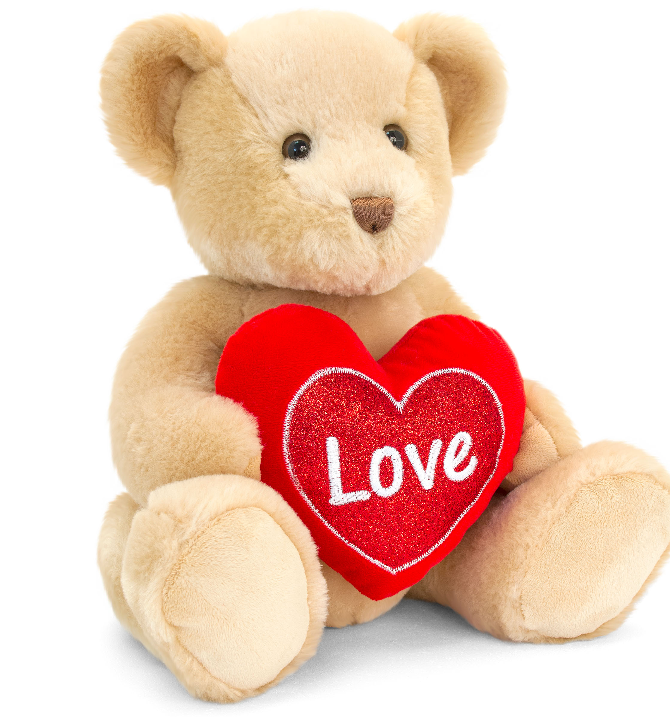
During the first we weeks we will be getting to know our friends and teachers. We will be learning about making the right choices and in particular some of the rules we have at school to keep us safe. We will be playing circle games to get to know each other, getting to know where everything is and learning how to tidy up!

The Nursery project for this half term is called “Why do you love me so much?” In this project, we’ll learn about love, families and how people are the same and different. We’ll pose for photographs and recognise ourselves, our names and our friends from a photograph display. Mirror, mirror on the wall… We’ll look at our reflections and talk about what we can see. In our cosy home corner, we’ll care for dolls and teddies. We’ll enjoy sharing books about love, feelings and families. Outside, we’ll practise following instructions and think about how our brilliant bodies move. We’ll create ‘All about me’ scrapbooks. Using our mathematical skills, we’ll measure and compare our hands, feet and heights. We’ll count candles and think about why we celebrate birthdays. Getting creative, we’ll make amazing artwork of people we love.

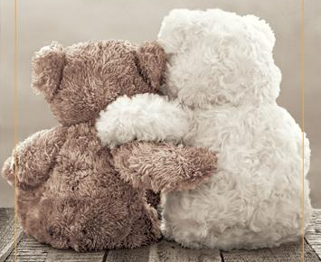
The Reception project is called “Do you want to be friends?” Friends are the family you choose! Do you want to be friends? Would you like to play with me? It’s time to find out more about friendship, being kind and working together. This half term, we’ll take a walk around our school to find out about the adults who work there and their workspaces, taking photos as we go. Back in the classroom, we’ll upload and print our photos to compile a ‘Who’s who?’ display of school staff. Working together, we’ll create friendship scenarios using Jelly Babies at the ‘Jelly Babies playground’, and we’ll create a ‘Class jobs board’, allocating responsibilities amongst ourselves. We’ll talk about friendship, being kind and helpful, loneliness and the things we like. What is our most cherished possession? In our literacy lessons we’ll discover new words to describe ourselves. In our mathematics lessons, we’ll share objects out fairly, and compare hand and foot sizes with our friends.

Please do not hesitate to catch your child’s teacher should you have any questions or queries. The best time to do this is at the end of the school day, after the teacher has handed over the rest of their class to the respective parents.

Mrs Kennett, Mrs Thornley, Mrs Allan and the Early Years Team

